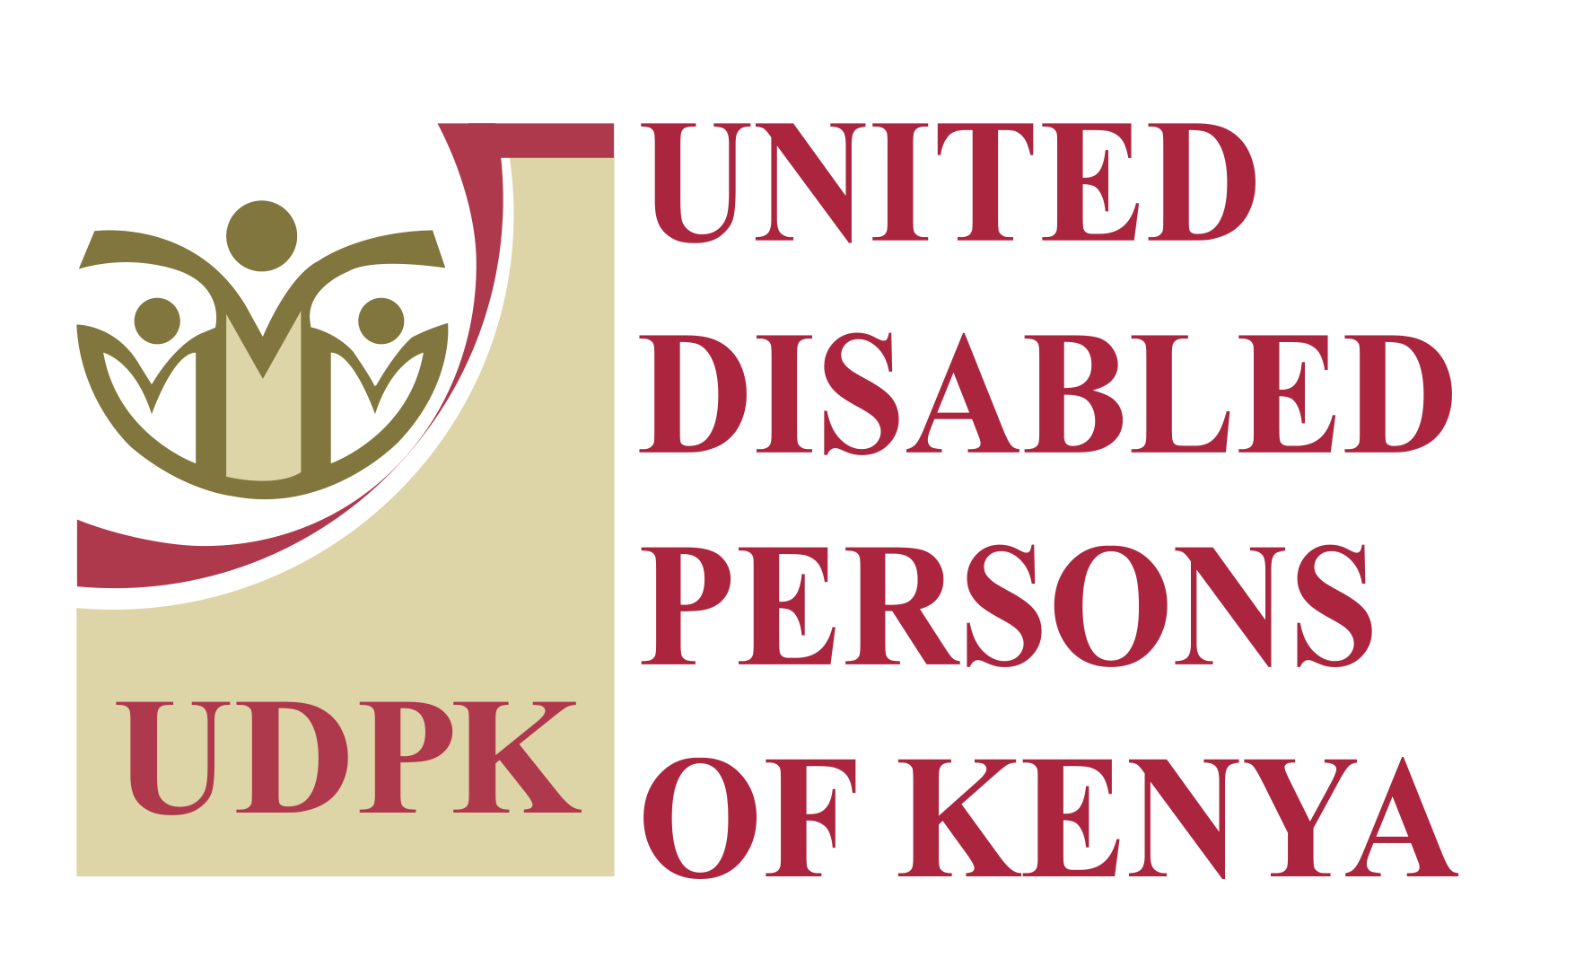

Inclusive Education Input Gathering on Kenya’s Six Education Bills
September 2026

Purpose and participation
UDPK, in partnership with Sightsavers, convened a two-day consultation to gather disability inclusion inputs for memoranda on Kenya’s six proposed Education Bills. Learners with disabilities, organizations of persons with disabilities and education institutions brought lived experiences and technical expertise into the review. The session examined how education reform could address barriers across the learning journey and support progression into further education and decent work.

What we did
We gathered perspectives from the Kenya Institute of Special Education, the Kenya Institute for the Blind and government directorates responsible for education and disability services. Discussions connected their mandates with learners’ experiences of accessing learning materials, assessments, support services and funding.
The accompanying UDPK analysis examined each Bill’s disability provisions, strengths and gaps, using constitutional obligations and the UN Convention on the Rights of Persons with Disabilities (CRPD) as its framework.
The review covered the following Bills;
- Basic Education Bill
- Kenya Institute of Curriculum Development Amendment Bill
- Kenya National Educational Assessments Council Bill
- Kenya National Qualifications Framework Amendment Bill
- Pre-Service Education and In-Service Training Bill
- Tertiary Education, Placement and Funding Bill, all of 2026

Priorities identified for the memoranda
- Accessible learning and assessment: timely Braille, large print, audio and accessible digital materials, alongside assessment arrangements responsive to individual requirements, including practical demonstrations of competence.
- Teacher preparation and learner support: inclusion competencies across teacher training, specialist expertise, early identification and intervention, and coordinated support throughout transitions.
- Placement and financing: accessible application processes, placement informed by available support, funding for disability-related costs and preservation of existing financial protections.
- Participation and accountability: direct representation of persons with disabilities, clear institutional responsibilities, disability-disaggregated data and mechanisms to monitor delivery of accommodations.
- Inclusive education across the system: stronger provisions for participation in mainstream education, with enforceable accessibility requirements and resources for implementation.

Contribution to Inclusive Education
The session generated stakeholder inputs to inform the memoranda, supported by analysis across all six Bills. It connected learners’ experiences with institutional responsibilities and identified concrete priorities for legislative advocacy. This work advances UDPK’s Inclusive Education agenda by bringing persons with disabilities into the reform process and developing proposals to improve access, participation, completion and progression.

